Protocol Section meeting 3

Date: 23 feb 2023

Time: 17.15

Place: Delta, Svea

Proposed agenda

§1. Opening of the meeting
Sam Sadeghi declares the meating open at 17:26

§2. Deciding the electoral roll
The electoral roll is defined at 41
The electoral roll changed to 39 at 18:19
The electoral roll changed to 40 at 18:26

§3. Choice of two adjusters
The meeting decides Anton Gårdman & Johanna Taremark to be adjusters

§4. Choice of 2 voice calculator
The meeting decides Olivia & Niklas Friberg to be voice calculators

§5. Election of the meeting chairman
The meeting decides Sam Sadeghi to be meeting Chairman

§6. Election of the meeting secretary
The meeting decides Daniel Jönsson to be meeting Chairman

§7. Meeting adjuncts
The meeting acknowledges that Henrik Guldbrandsson is not allowed to vote and Emelie Leman (left the meeting at 17:35)

§8. Approval of the agenda
Styret proposes a change to the agenda adding 1 (one) extra item
The meeting accepts this change and the rest of the agenda.

§9. Correct calling of the meeting
The meeting decides that the calling was correctly announced

§10. Messages
- Kårledningen
Promotes the use the unions app, val till FUM, Vd poster i teknolog… , technology äska om man har ett nytänkande evenemang

- Styret
Styret presents their Seeking of a new Styret and the upcoming events Vinterspelen and Räkkryssningen

- Frasses
Frasses informs that they are going to have a building team in the cortege

- SjöNollK
NollK informs that they are starting to contact all committed to plan events during the mottagning

- SHIPPING
They have a study trip coming up and starting their aspning

- SJÖLOG
The mässa went good and have started their aspning

- Fartygskommittén
Fartyg will continue their aspen due to low attendance, They also present what tools they have to lend out.

- Dickson IF
A futsal tourney 4 of march and seek players for it.

- PubF
Their aspen is ending and have continued to host pubs

- Olivias Byssa
Byssans aspningen will also continue on to lp4

- SJUU
SJUU has started up again and is seeking new members.

- CHAMM
no chamm attending

- SJÖN
Sjön has been attending a workshop at sjöfartsverket for equality at sea. Sjön is also seeking new members during lp4

- FuM
No FuM attending

- Sjökortet
Sjökortet has had their aspen and will select new members later in the meeting, they have and will continue to take pictures at upcoming events.

- Sjö6
Sjö6 is getting closer to being able to hold the gasque, they have puffed their first gasque. The plan is to be able to hold their first gasque during the Mottagning.

- Trädgårdsmästeriet
The trädgårdsmästare of trädgårdsmästeriet held a presentation about biodiversity.

§11. Financial statement for the year 21/22
Styrets Cashier presented last year report of results

§12. Financial situation for the year 22/23
Styrets Cashier presented this years budget and äskningar for 22/23

§extra. Exoneration of responsibility
The meeting decides to relive the duty of responsibility for the following persons:
Shipping:
2020:
Fanny Leandersson, Oscar Jansson
2021
Mira Börjesson, Joakim Erlandersson
SJÖLOG:
2020
Filip Pehrsson, Fredrik Wass
2021
Filip Pehrsson, Trifah Muradi
Frasses:
2020
Ruben Hagberg, Rodrigo Heriquez Carvajal
2021
Ruben Ljunggren, Caroline Janrik
SjöNollK
2020
Trifah Muradi, Jon Håkansson
2021
Filip Andreasson, David Broms
Fartygskommiten
2021
Philip Bröms, Ruben Ljunggren
Styret
2020
Fredrik Haakon Olin, Tobias Hopstadius, Stephanie Lindh, Rodrigo Heriquez Carvajal, Moa Olsson, Arthur Victor Therman
2021
Felix Ström, Sam Sadeghi, Filip Andreasson, Anna Jernå, Viktor Hellman, John Glimåker

§13. half-year report of business plan
Postponed to next section meeting

§14. Propositions
Styret has no propositions for the meating

§15. Motions
No motions has been submitted for the meeting

§16. Elections

sjökortet,
- The meeting accepts Magdalena Annaorazova as chairman
- The meeting accepts Fredrik Löfgren as Cashier

Dicksson,
- The meeting accepts Niklas Friberg as Chairman

Fartygskomitén
- Postponed their election to Section Meeting 4

Sjön,
- Postponed their election to Section Meeting 4

§17. Other questions
No other questions.

§18. Prize drawal
Anton Gårdman wins the pricedrawl

§19. Ending of the meeting
Sam Sadeghi declares meetings end at 18:34

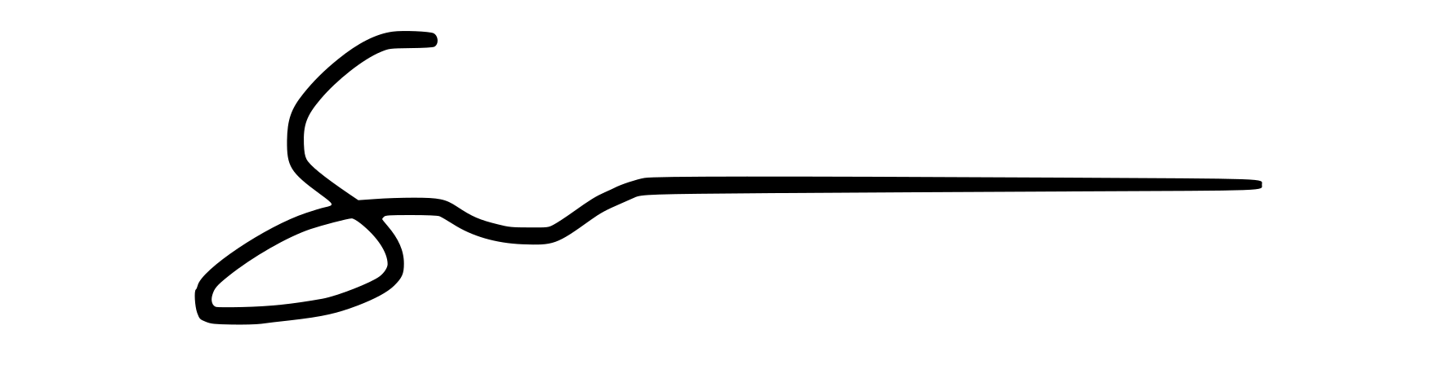

Sam Sadeghi, Meeting Chairman

Daniel Jönsson, Meeting Secretary

Anton Gårdman, Protocol Adjusters

Johanna Taremark, Protocol Adjusters

Olivia Hutchinson-Kay, Voice Calculator

Niklas Friberg, Voice Calculator

