Protocol Section meeting 3

§1. Opening of the meeting
Kevin Johansson declares the meeting open at 17:24.

§2. Deciding the electoral roll
The electoral roll is defined at 43 at 17:25.
The electoral roll changed to 44 at 17:27.
The electoral roll changed to 45 at 17:32.
The electoral roll changed to 46 at 18:06.
The electoral roll changed to 45 at 18:09.
The electoral roll changed to 43 at 18:30.
The electoral roll changed to 42 at 19:10.
The electoral roll changed to 41 at 19:15.
The electoral roll changed to 42 at 19:20.

§3. Choice of two adjusters
The meeting decides Sam Sadeghi and Marcus Leyon as vote counters a nd adjusters.

§4. Choice of 2 voice calculator
The meeting decides Andreas Gustafsson and Anton Gårdman as vote counters and adjusters.

§5. Election of the meeting chairman
The meeting decides Kevin Johansson to be meeting chairman.

§6. Election of the meeting secretary
The meeting decides Magdalena Annaorazova to be meeting secretary.

§7. Meeting adjuncts
The meeting acknowledges that Nathalie Bonnier is not allowed to vote.

§8. Approval of the agenda
The agenda is approved except for paragraph 11, which is removed.

§9. Correct calling of the meeting
The meeting decides that the calling was correctly announced.

§10. Messages
- Styret
Vinterspelen will soon take place. Main sponsor for the trip is DFDS.

- Frasses
Announces ”Hönsafest” which will take place 21st of march. Committees will contribute in different ways and tickets will be sold soon. More information will come.

- SJØK
No information to disclose.

- SHIPPING
No information to disclose.

- SJÖLOG
Aspning will take place in April.

- SJÖ6
Appreciates everyone who attended gasquen 26th of January. Next gasque will take place place 12th of April. They are planning for CM as well.

- Dickson IF
No information to disclose.

- PubF
Announces that their aspning is currently underway.

- Olivias Byssa
They have completed the aspning. It went well, and they will select four new individuals, none of whom are present during the meeting. The aspning is not yet concluded. Contact Byssan if you wish to aspa.
New grills are expected to arrive.

- Sjökortet
They have completed their aspning and will announce their new members during the meeting.

- SJUU
Sjösektionen needs members for SJUU.
The third pluggfika will be taking place on Tuesday, the fifth of march.

- SJÖN
This year, the chairman of SJÖN is also the construction manager during the cortège. The deadline for registration is February 28th. There will be a meeting on Sunday, February 25th. Their aspning will take place during study period 4.

- PPSC
They will attend the Hönsafest.

- Trädgårdsmästeriet
They continue to share valuable information about plants.

- Kårledningen
A new investigation has been initiated regarding Chalmers and the Sjösektionen (Nautical Section). It is not decided whether the nautical section will remain. There is an inquiry into whether the nautical section should be retained or not. A working group on the election for the relocation will be formed. The Nautical Board will be part of the working group to represent the students. In May, a report on the recommended course of action will be released. The final decision will be based on the report.

§11. Financial situation for the year 23/24
Presented during the meeting.

§12. Half-year report of business plan.
Presented by Harry O’Connor during the meeting.

§14. Discharge of former responsibility positions.
No discharges were announced.

§15. Propositions
- Yet to be proposed

§16. Motions
- Increase Of Responsibility Positions In SJÖ6 (attached below)

The motion was accepted.
- Change Of Section Saint (attached below)
This motion was denied.

- Adoption Of Name For President in Frasses (attached below)
The motion was accepted.

§17. Elections

- Sjökortet
  - Chairman
Valberedningen nominates Lisa Demselius
Lisa Demselius is approved as the Chairperson of SjöKortet.
  - Cashier
Valberedningen nominates Linus Thorsson.
Linus Thorsson is approved as cashier of SjöKortet.

*Additional information:
The meeting elects Fredrik Löfgren to be the new meeting secretary due to Magdalena needing to resign.

- Byssan
  - Chairman
Valberedningen nominates Linus Hedeé to continue his chairmanship another year.
Linus Hedeén is approved as chairman of Byssan.
  - Cashier
Valberedningen nominates Alexandra Olofsson as Cashier of Byssan.
Alexandra Olofsson is approved as Cashier of Byssan.

§18. Other questions
FuM - Start a party to be able to represent Sjösektionen at FuM. If you are interested, please inform us.

§19. Prize drawal
Prize drawal was finalized.

§20. Ending of the meeting
The meeting ended at 18:40.

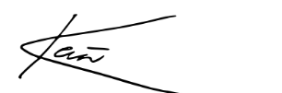

Meeting chairman, Kevin Johansson



Meeting secretary, Magdalena Annaorazova

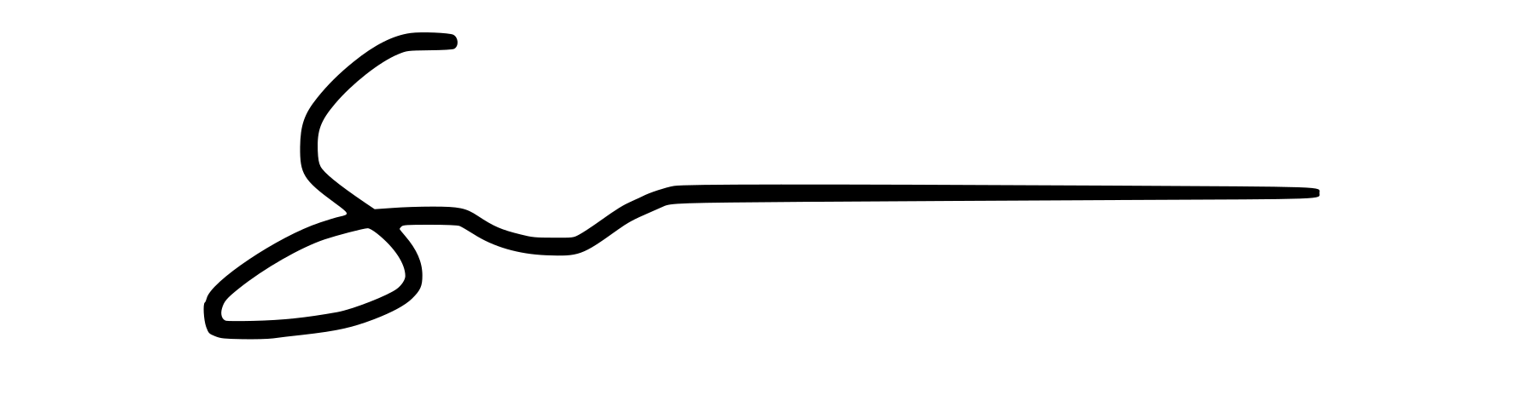

Protocol adjuster, Sam Sadeghi

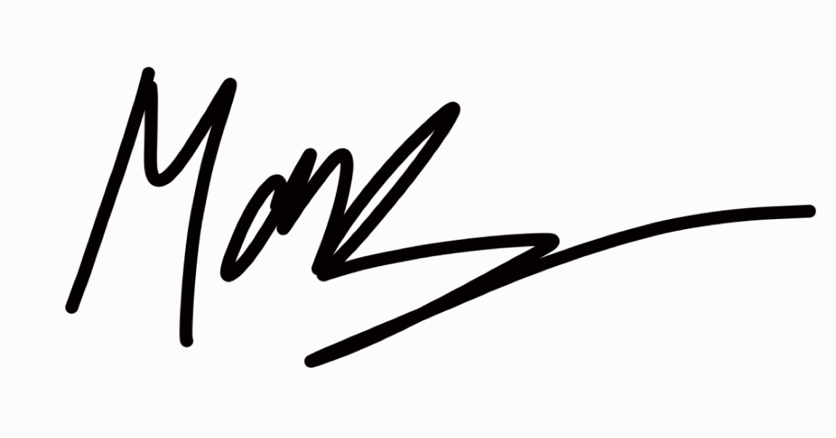

Protocol adjuster, Marcus Leyon

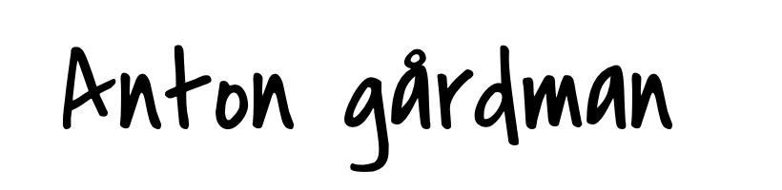

Voice calculator, Anton Gårdman

A.G

Voice calculator, Andreas Gustafsson

MOTION 1.
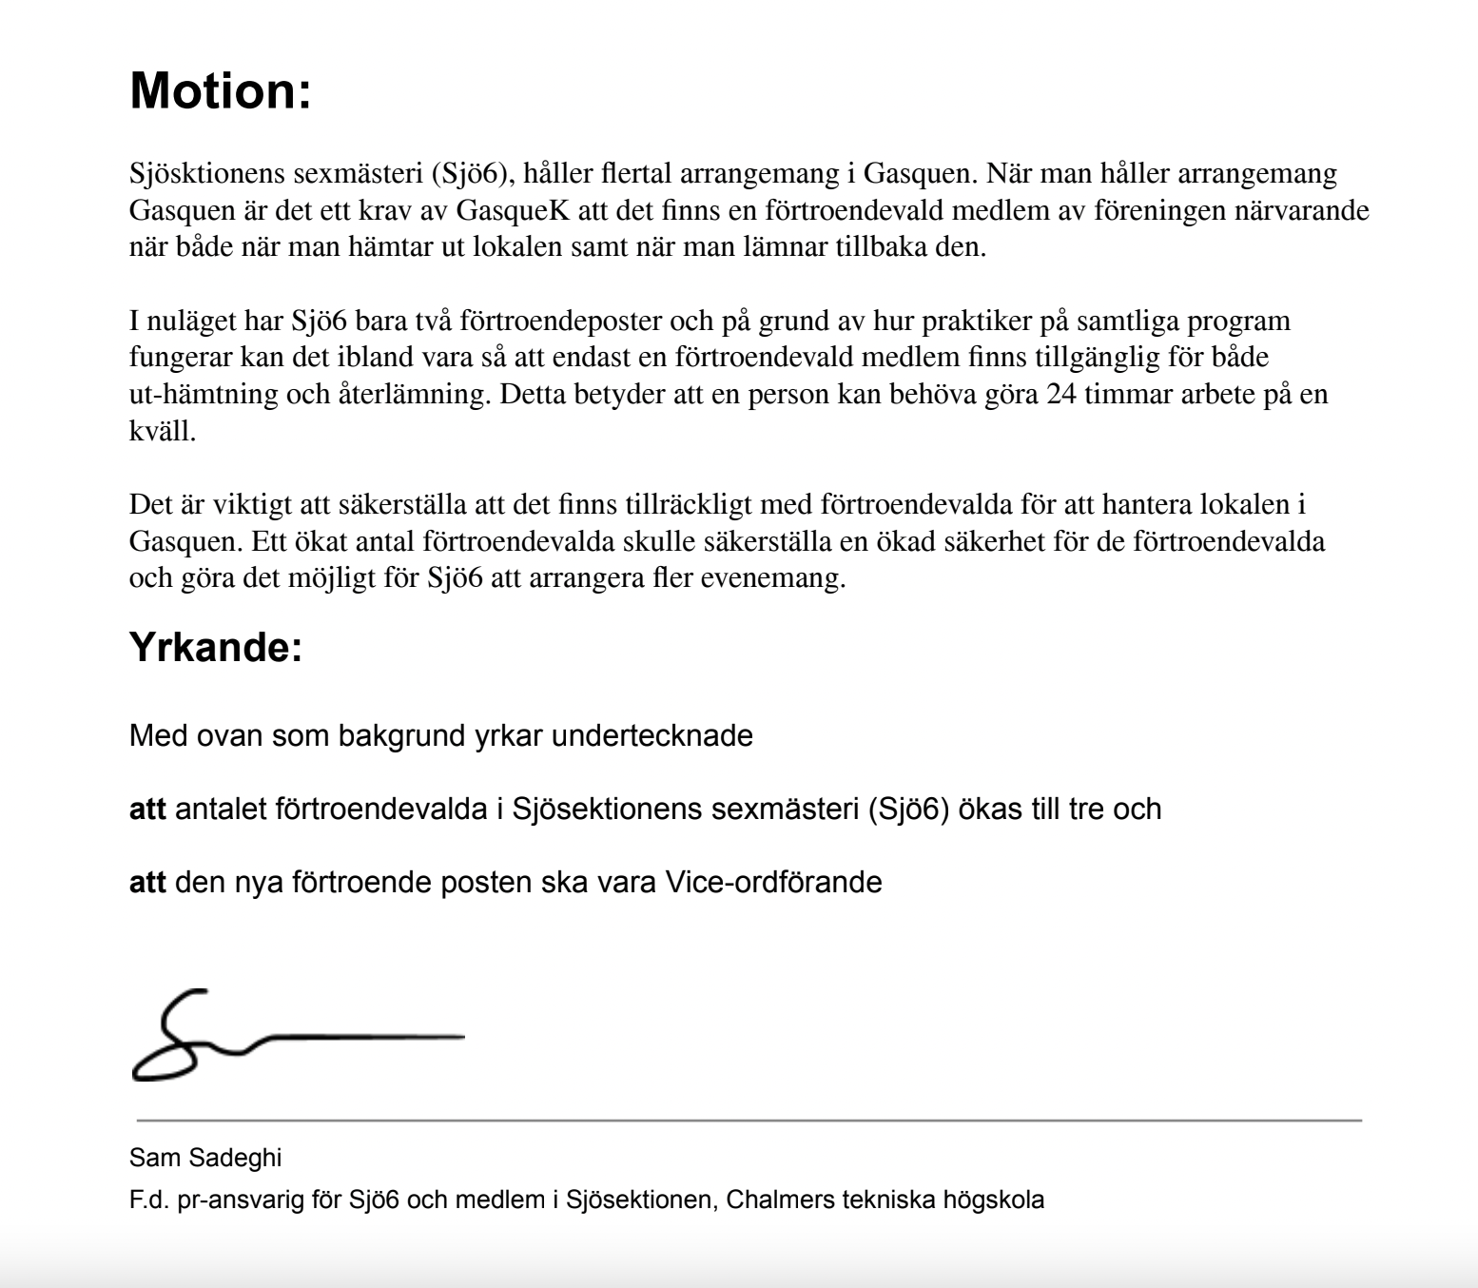

MOTION 2.

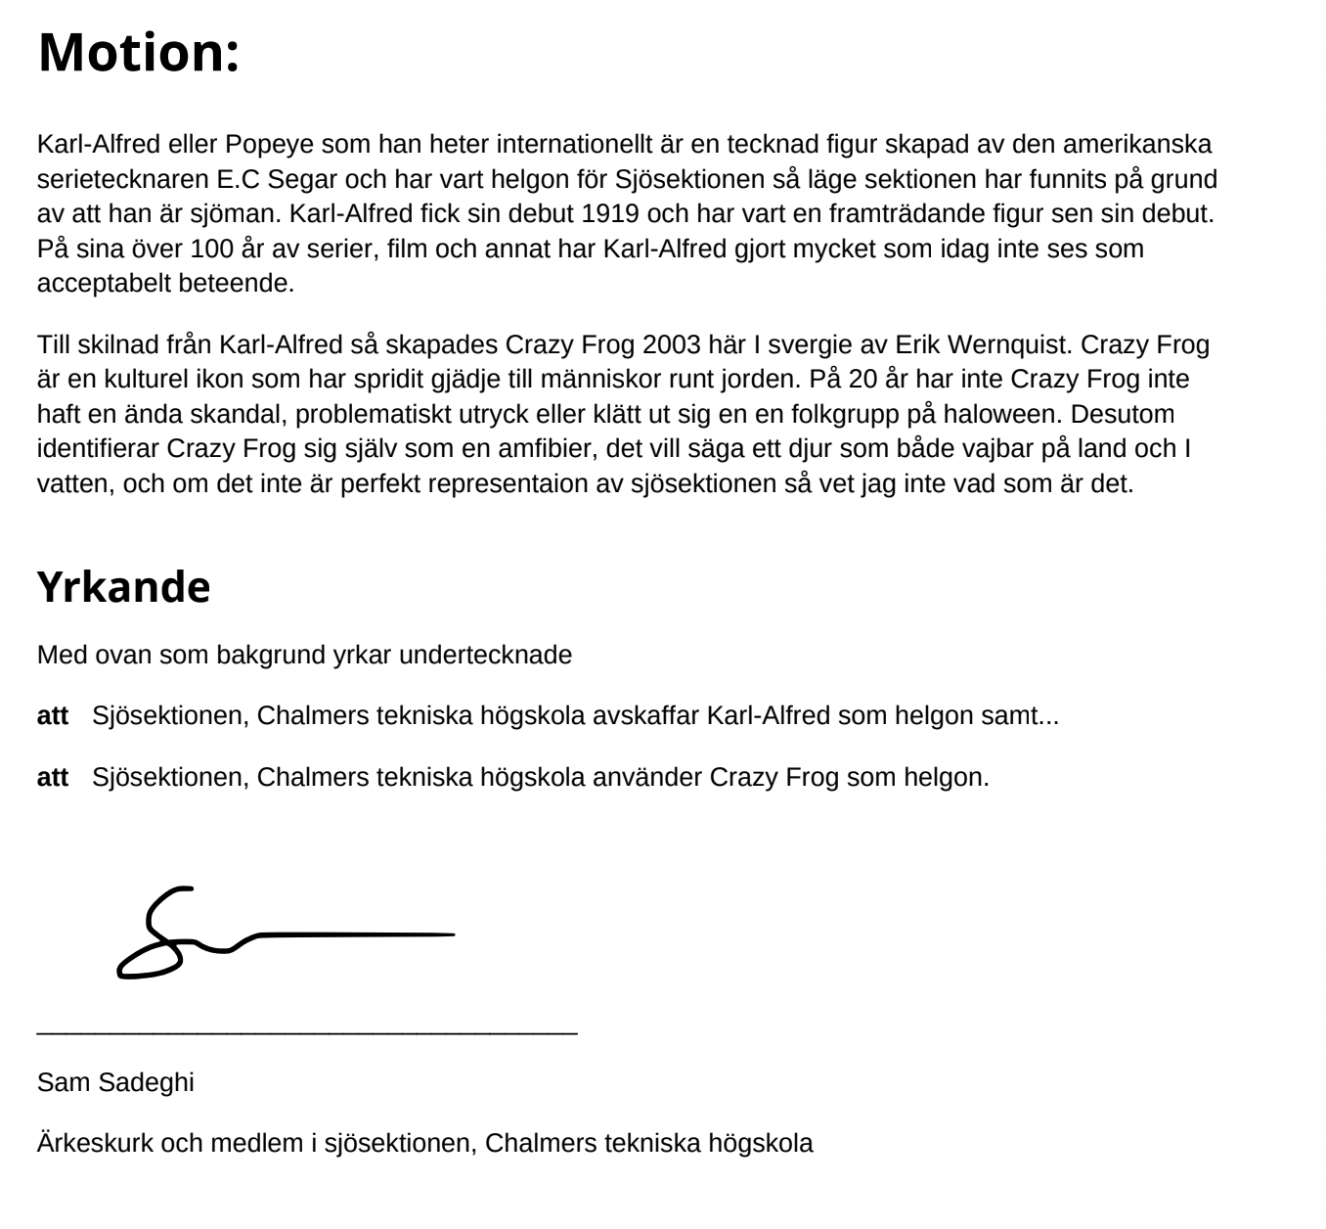

MOTION 3.
