Protocol
§1. Opening of the meeting
The meeting was opened at 17.20.

§2. Deciding the electoral roll
The electoral roll was 42.

§3. Choice of two adjusters
Anton Gårdman and Kevin Johansson were chosen as adjusters.

§4. Choice of 2 voice calculators
Lukas Sandén and Olivia Hutchinson-kay were chosen as voice calculators.

§5. Election of the meeting chairman
Linus Hedeen was elected as the meeting chairman.

§6. Election of the meeting secretary
Sam Sadeghi was elected as the meeting secretary.

§7. Meeting adjuncts
No Meeting adjuncts present.

§8. Approval of the agenda
The agenda was approved by the meeting.

§9. Correct calling of the meeting
The meeting was called correctly.

§10. Messages
Kårledningen: Thanked for cortage, announced new kårkedning, new features in the app, and the employment unit.
Styret: Thanked for räkkryssning and aspning.
Frasses: Thanked for cortage, announced a sittning, and announced that tickets will be available next week.
SjöNollK: Announced a preliminary schedule and asked for phaddrar.
Shipping: Announced a new board, 14 different activities, and a record turnover.
Sjölog: Announced an upcoming inval.
Fartyg: Announced that Oliva V's motor is broken and stolen.
PubF: Introduced new pubf members and mentioned the involvement of the fire department.
Olivias Byssa: Thanked the styret for vinterspelen and for the cortage.
SJUU: Announced that the work for starting SJUU has been prepared.
SJÖN: Announced the discovery of successors, who will be elected next time.
Sjökortet: Announced a new Facebook page with new pictures of the associations.
Trädgårdsmästeriet: Announced plans to test Sigge.

§13. Preliminary budget for the year 23/24
The Preliminary budget was approved by the meating.

§13. Propositions
No propositions were presented.

§14. Motions
Motion Jämlikhetskomiten Sjön:
The last sentence was removed from the motion, and the meeting approved it.

§15. Elections
Olivias Byssa:
-Chairman: Sam Sadeghi
-Cashier: David Broms

Fartygskomitén:
Election postponed to next meating

Shipping:
-Chairman: Emma Henricsson
-Cashier: Linus Lagertaft

Styret:
-Chairman: Harry O'Connor 990919-4012
-Cashier: Anton Gårdman 010913-2977
-Vice Chairman: Kevin Johansson
-Utbildningsansvarig: Erik Broberg
-Alf: Andreas Gustafson
-Samo: Fredrik Löfgren
-Informationsansvarig: Magdalena Annaorazova

Sjölog:
-Projektledare: Oscar Nolstedt
-Cashier: Mathias Kålberg

§16. Other questions
Samuel Håpe Karlsson was appointed as an honorary member of Sjösektionen.

§17. Prize drawal
Alexandra won the prize draw.

§18. Ending of the meeting
The meeting ended at 18.48.

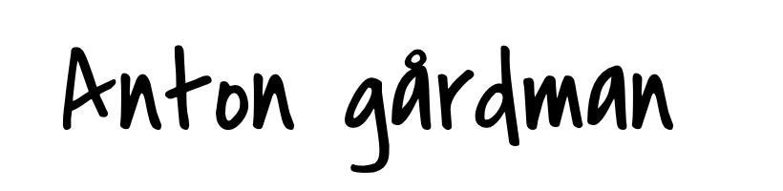

Anton Gårdman meeting adjuster

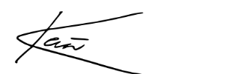

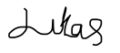
Kevin Johansson meeting adjuster

Lukas Sandén voice calculator

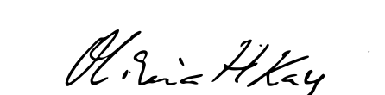

Olivia Hutchinson-kay voice calculator

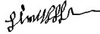

Linus Hedeen meeting chairman

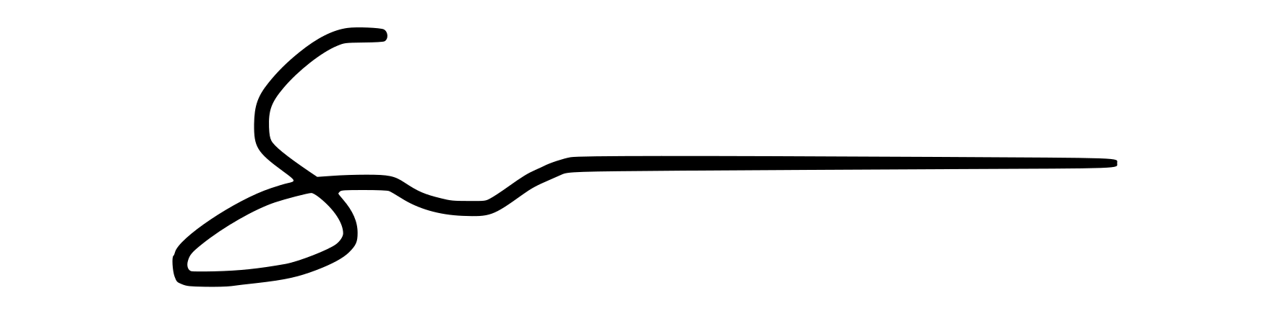

Sam Sadeghi meeting secretary

